Meditation to Become Rich and Prosperous (Subagh Kriya)
“It’s a complete set. This is all called Subagh Kriya. If God has written with His own hands that you shall live under misfortune, then by doing Subagh Kriya you can turn your misfortune into prosperity, fortune, and good luck.”
"To become rich and prosperous with wealth and values, is to have the strength to come through. It means that transmissions from your brain, and the power of your intuition can immediately tell you what to do. You will be in a position to change gears. If you need to go in reverse, you can go in reverse. If you need to go forward, you'll go forward. This is a very old and simple system." © The Teachings of Yogi Bhajan - 6/21/96

The exercises in this set must all be done for the same length of time,
either 3 minutes each or 11 minutes each.
Part One
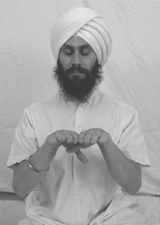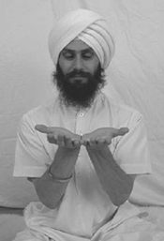

Position: Sit in Easy Pose with a light jalandhar bandh. Elbows are by the sides, forearms angled up and outward with the fingers at the level of the throat. Then begins with the palms facing down. Alternately hit the sides fo the hands together. The Mercury (pinky) fingers and the Moon Mounds (located on the bottom of the palms) hit when the palms face up. When the palms hit facing down, the sides of the jupiter (index) fingers touch and the thumbs cross below the hands, with the right thumb under the left. Yogi Bhajan said that the thumbs crossing this way is the key to the meditation.
Eyes: Look at the tip of your nose, through eyes 9/10th closed.
Mantra: Chant the mantra "Har, Har." Alternately strike the Moon area and the Jupiter area as you chant Har with the tip of your tongue, pulling the navel with each Har. Your eyes are focused at the tip of your nose. Chant continuously from the navel, using the tip of the tongue. (This meditation was taught to the rhythm of Tantric Har by Simran Kaur.)
Time: Continue for 3-11 minutes. Yogi Bhajan has said, "You should not do it more than 3 minutes when you are working during the day, or you will become too rich. I am not joking. Doing it for 11 minutes a day is more than enough. Doing it too much will be greed. It stimulates the mind, the moon center, and Jupiter. When Jupiter and the moon come together, there is no way in the world you will not make wealth."
Note: Part One can be done on it's own for prosperity.
"This meditation stimulates the mind, the moon center and Jupiter. When Jupiter and the moon come together, there is no way in the world you will not create wealth."

Part Two
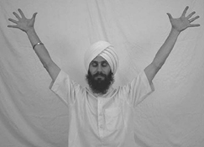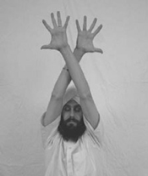

Position: Stretch your arms out to the sides and up at a sixty-degree angle. Spread your fingers wide, making them stiff. The palms face forward. Cross your arms in front of your face. Alternate the position of the arms as they cross: first the left arm crosses in front of the right and then the right arm crosses in front of the left.
Continue crossing the arms, keeping the elbows straight and the fingers open and stiff. This movement is also done to the rhythm of Tantric Har by Simran Kaur, but this time you do not chant.
Eyes: The eyes remain closed.
Mantra: Keep in rhythm with the Tantric Har tape, but do not chant this time.
"I'm going to give you a very handy tool, one that you can use anywhere, and you'll become rich. To become rich and prosperous, with wealth and values, is to have the strength to come through. It means that transmissions from your brain and the power of your intuition can immediately tell you what to do."

Part Three
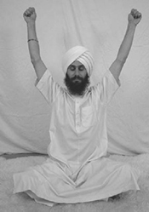
Position: This is the English mantra. Keep your arms out and up at sixty degrees as in the previous exercise. With your hands, make a fist around your thumb, squeezing your thumb tightly as if you are trying to squeeze all the blood out of it. Move your arms in small backward circles as you continue squeezing your thumb. Your arms are stretched and the elbows stay straight. Chant the mantra “God” powerfully form your navel. One backward circle of the arms equals one repetition of “God.” The speed and rhythm of the chanting is the same as in the previous exercises. Move powerfully so that your entire spine shakes, you may even be lifted slightly up off the ground by the movement.
Part Four
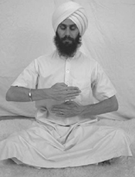
Position: Bend your arms so that your elbows point to the sides. The forearms are parallel to the floor and the palms face the body around the level of the diaphragm. The right hand moves up a few inches as the left hand moves down. The left hand moves up as the right hand moves down. The hands move alternately up and down between the heart and navel. As the hands move, chant "Har Haray Haree, Whahay Guroo" in a deep monotone with one repetition of the mantra approximately every 4 seconds. Chant from your navel.
If you are practicing the exercises for 11 minutes each, then you will chant the mantra out loud for 6 minutes, whisper it strongly for 3 minutes and then whistle it for 2 minutes. If you are practicing the exercises for 3 minutes each, then you will chant the mantra out loud for 1 minute, whisper it strongly for 1 minute, and then whistle it for 1 minute.
Chant: Har haray haree wahay guroo

Part Five
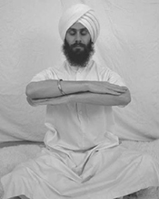
Position: Bring the arms in front of the chest. Bend the arms at the elbows, palms facing down, rest the right forearm on the left forearm. Keep the arms steady.
Eyes: Close your eyes and breathe long and deep. Keep the spine straight and keep the arms parallel to the ground; don't let them fall.
Breath: Breathe slowly and deeply so that one breathe takes a full minute. Inhale for 20 seconds, hold for 20 seconds and exhale for 20 seconds. Breathe consciously.
Testimonial:
"Sat Nam,
I thought you might love to hear about my success with Subagh Kriya. I started a 40-day commitment to this kriya last week. My job (among other things) is in non profit fundraising for environmental education and stewardship projects. On the first day I received an unexpected cheque for $250 - nice. On the second day I received an unexpected $25,000. On the fourth day, another $10,000 - totally unexpected with a letter from a funder saying "we reviewed your file and decided in fairness you should be granted additional funds". Today -- about ten days in to the meditation, I've received yet another $10,000 and support in principle for a multi-million dollar project that I have been holding the vision of for two years. I clearly have a good deal of receptivity going on for good fortune on behalf of my workplace...now I am going to add personal prosperity into the mix. Wahe Guru"

